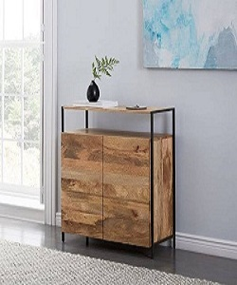

Drawer

$32.67

Availability: In stock

Description

Pine Frame keeps it durable and brings classic style. Stands nearly 23 high to work as the perfect drawer in any room. Added shelf at the base is perfect for extra storage. Different colors available, right choice for future durable and beautiful.